**Highly Confidential Security System**

1. Introduction

1.1Purpose:

“World is shrinking in a very faster pace”-In this fast forward life remembering all the confidential data like password, bank account no, Insurance policy No, PAN NO, Driving License No, Password Port no, All education certificate Numbers, Some highly value scan copy, some confidential photo and music ,videos. So we can develop highly security web application (new security algorithm and hardware system) .so we can store all confidential data in single credentials.

1.2Scope:

Initial functional requirements will be: -

¬Secure registration and profile management facilities for users.

¬Nobody can take chance of becoming victim of thieving

of its confidential/personal information. Protect our personal information such as various passwords, usernames, images, videos, etc. with highly confidential security system that will let us rest our head knowing that no anyone can used/misused our confidential data.

The finger-print scanner is used for the purpose of setting password and without entering password that means login no one can get access to the system, even also administrator also has to login first then he/she get the access to the system.

What's the biggest threat to our data is snooping, or device theft, or hacking, or simple carelessness. You could lock down your files, folders, drives, and devices with password protection; encrypt critically important data on the fly; store it and back it all up to a secure online storage locker that automatically syncs data and lets you access it on mobile devices? Include stealth mode, hack protection and logging (including forced shutdown); adds enhanced drag-and-drop capability, easier unlocking, and automatic backups of encrypted data to your online storage share.

On first run, you're prompted to create a master password and enter it twice, consecutively: it's important to get it right it is a full suite solution letting you keep your personal files encrypted and locked, while keeping an automatic and real-time backup of encrypted files to an online storage. No need to decrypt or manually backup your files.

3

You can activate password security and restrict access to different parts of the application using an admin level master password. You can run the application in complete stealth using the Stealth Mode feature. You can also catch and perform actions on repetitive hack attempts and on basis of incorrect password logs and you can set automatic duration based protection for your data security, so you know that your stuff is no longer accessible to anyone else when you're away from your PC.

1.3Definitions, Acronyms and Abbreviations

Modules used:

Admin module:

a.It maintains the user details. It grants privileges to the user to access the data from internet.

b.It verifies the user whether he is valid or not. Admin will be acts as a server for the users.

User module:

The user is who going to access the data. He will provide with the user id and password by the server.

Registration module:

When new user wants to access the data he wants to register and submit his details to the server.

Public people:

The people who are not registered to the server can only view the data he can’t access the data.

He is non member of the system.

1.4References

¬IEEE SRS Format

¬Search engines.

1.5Overview

The system HCSS is a powerful web application which can securely store confidential data like passwords for credit cards, bank accounts, confidential photos, music and video, very valuable scanned copies, driver's license and passport numbers, and insurance policy numbers are just a sampling of what we need to keep track of. As each piece of information is entered into the HCSS system, a separate database entry is created. Application’s retrieval interface will display each entry by name, but categorize and group together types of entries, such as bank accounts, credit card accounts, and other passwords.

4

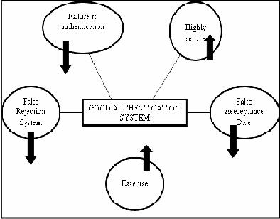

2.Overall Description

2.1Product perspective:

Busy life style can’t remember all confidential data like all mail id, password, all bank account no, insurance policy no, PAN no, all education certificate numbers , some highly value scan copy, some confidential photo and music, videos we can store all confidentially in single credentials.

2.1.1 Hardware interfaces:

CLIENT SIDE:

It is a web based application.

It is a client side application. It can be accessed by any web browser like Mozilla Firefox, Google chrome...etc.

SERVER SIDE:

It maintains the all client access. It acts as a website to retrieve the data.

2.1.2Software interfaces:

1.Client interface

a. Status protocol

5

i. unregistered client.

The unregistered client want to login to the server then only he can access the data.

ii. registered client.

The registered client can access the data through login to the server using client id and password.

b.Modification protocol. i. registered client.

The registered clients have the rights to modify the details of the client.

2.1.3 Memory constraints

RAM-1GB

Hard disk- 500 GB i3 processor.

2.2Product function

HCSS means protecting information and information systems from unauthorized access, use, disclosure, disruption, modification, perusal, inspection, recording or destruction.

At the time of entering confidential data and information depending on the type of information it is, the system will prompt the end user for related information. Later, when the end user needs to retrieve data, the user will need to access the application using a single password.

2.3 User Characteristics

ADMIN: DATA SERVER:

The Administrator is the super user and has complete control over all the activities that can be performed. The administrator can also view and delete entries in the users.

USER:

The user is the member who wants to access the data from the server. At his busy schedule there is the chance to forget the password. So he trusted on HCSS to save his details.

PUBLIC PEOPLE:

The people who are not registered to the server can only view

6

the data he can’t access the data. He is non member of the system.

2.4. Constraints:

Interfaces to other application:

The new system needs access to the current database of the clients. Any new modification requests as to update in the database. Hence proper and integration database required.

Safety and security consideration:

Every access is password protected and any sort of unauthorized.

Audit functions:

Double entry and data redundancy should be taken care of.

2.5 Assumptions and dependencies:

Verification of the user details should be verified as soon as possible. The user should login using use rid and password, if he forget his password he cannot login to the server and access the data.

2.6. Apportioning of requirements:

We can implement HCSS facility to track more accurately. When the users forget his details the HCSS system will help him to retrieve the password and more details about that person.

3.Specific requirements:

3.1External interfaces:

i)Administrators:

⎫Database Management: Control the database and keep track of all the details of the user who were registered in the HCSS system.

¬Preconditions: Administrator is already logged in.

¬Normal flow of events:

1.Normal check of the database by the Administrator.

2.Updating the database (if required).

7

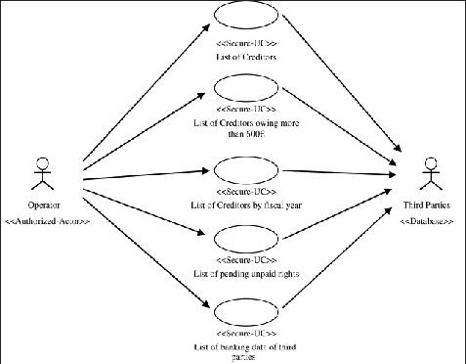

3. The updating will be done only the user with the permission of the

admin.

¬Post Condition: Always updated database.

⎫Giving Permission to users: Allow with the users and give permission to access their

|  |  |
| --- | --- |
| data | under the site after checking whether the user is valid user or not. |

¬Preconditions: 1) Administrator is already logged in.

2)Users access the data from Administrator.

¬Post Condition: possibilities of updating of the user details by the user.

⎫View all details: View the details of all users and control the whole site.

¬Preconditions: Administrator is already logged in.

¬Normal flow of events:

1)Administrator views the details of all users.

2)Controls the whole site.

¬Alternate flow of events: None.

¬Post Condition: Everything is completely.

Use case diagram.

ii) User:

8

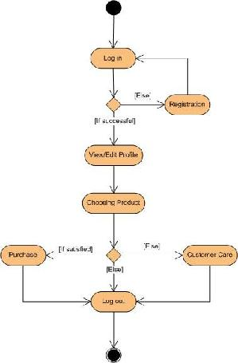

¬Preconditions: User must have a valid user ID.

¬Normal flow of events:

1)Log in.

2)View and edit Own Details

3)Retrieving the data.

4)Access the data.

5)Logout

¬Alternate flow of events:

1)New user registration

¬Post Condition: A happy user!

iii)Public people:

¬Preconditions: Administrator is already logged in.

¬Normal flow of events:Visiting the Site

¬Alternate flow of events: None.

¬Post Condition: Proper separation between users and public people.

9

iv)Accounts details:

Accounts details of a user are maintained by the administrator. He is responsible for the data’s and details of the user who was registered in the database.

Consulting with Administrator: Consult with the Administrator about details. He can retrieve a losed data from the administrator.

3.2: Functional Requirements:

The act of ensuring that data is not lost when critical issues arise. These issues include but are not limited to; natural disasters, computer/server malfunction, physical theft, or any other instance where data has the potential of being lost. Since most information is stored on computers in our modern era, information assurance is typically dealt with by IT security specialists. One of the most common methods of providing information assurance is to have an off-site backup of the data in case one of the mentioned issues arises.

Fingerprint Identification is the method of identification using the impressions made by the minute ridge formations or patterns found on the fingertips. No two persons have exactly the same arrangement of ridge patterns, and the patterns of any one individual remain unchanged throughout life. Fingerprints offer an infallible means of personal identification. Other personal characteristics may change, but fingerprints do not. Fingerprints can be recorded on a standard fingerprint card or can be recorded digitally and transmitted electronically to the FBI for comparison. By comparing fingerprints at the scene of a crime with the fingerprint record of suspected persons, officials can establish absolute proof of the presence or identity of a person.

3.3Performance Requirements:

24x7 availability

High Speed

Compatibility for all the Web Browsers

Match able to most of the file types

Wide listening platforms and compatible with players.

3.4Logical database requirement:

3.2.1Client Mandatory Information:

Each Client shall have the following mandatory information: first name, last name, phone number, PAN card number, address, postal code, city, country, Client ID, Form number.

10

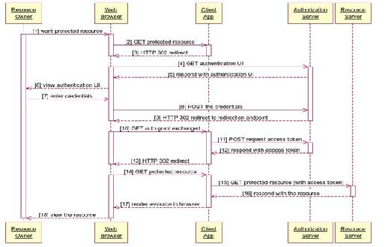

3.2.2 Update Client Information:

The client database will be updated by the user who wants to modify his details. The admin will grant privilege to the user to modify his own information only when after checking whether he is a valid user or not.

3.2.3 Search for Client:

The Database will allow the user to access the client’s (users own details) information by logging into the database using user id and password.

3.5 Design Constraints:

3.5.1 Sequence Diagram:

Database:

The system shall use the SQL Database.

OperatingSystem:

The Development environment shall be Windows XP, vista, windows7.

Web-Based:

The system shall be a Web-based application.

11

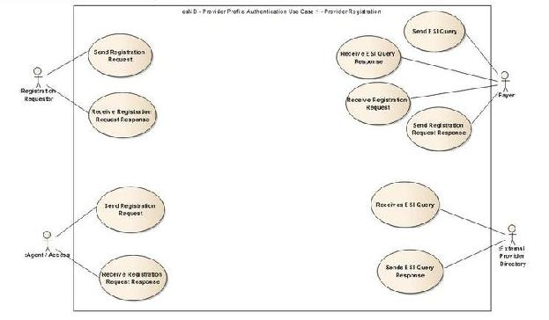

3.5.2 Use case Diagram:

Use case diagram is used to capture the dynamic nature of a system. It consists of use cases, actors and their relationships. Use case diagram is used at a high level design to capture the requirements of a system.

So it represents the system functionalities and their flow. Although the use case diagrams are not a good candidate for forward and reverse engineering but still they are used in a slightly differently way to model it.

3.5.3 CLASS DIAGRAM:

Class diagrams are the most popular UML diagrams used by the object oriented community. It describes the objects in a system and their relationships. Class diagram consists of attributes and functions.

12

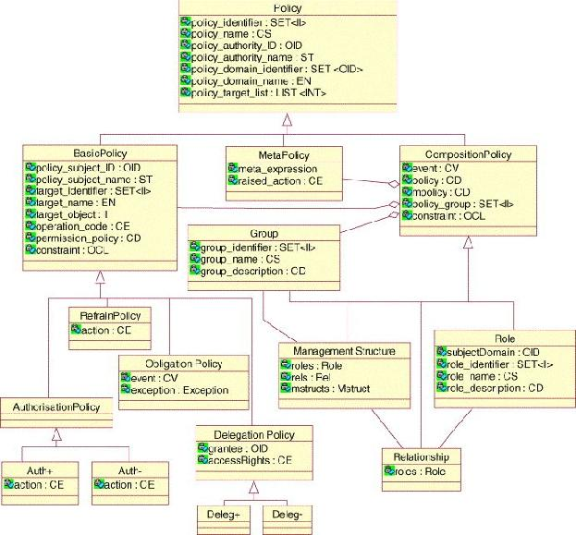

A single class diagram describes a specific aspect of the system and the collection of class diagrams represents the whole system. Basically the class diagram represents the static view of a system.

Class diagrams are the only UML diagrams which can be mapped directly with object oriented languages. So it is widely used by the developer community.

13

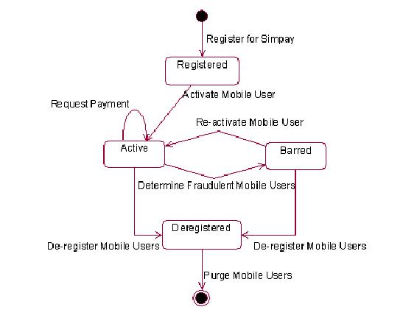

3.5.4 Activity Diagram:

Describe the dynamic aspect of the system. Activity diagram is basically a flow chart to represent the flow form one activity to another activity.

Activity diagram is another important diagram to describe dynamic behavior. Activity diagram consists of activities, links, relationships etc. It models all types of flows like parallel, single, concurrent etc.

Activity diagram describes the flow control from one activity to another without any messages. These diagrams are used to model high level view of business requirements.

3.5.5 Standards Compliance:

Standards’ are documented agreements containing technical specifications or other precise criteria to be used consistently as rules, guidelines, or definitions of characteristics, to ensure that materials, products, processes and services are fit for their purpose.

Compliance is the extent to which software developers have acted in accordance with Practices set down in the standard Consistency between actual development process and normative models embedded in standards.

14

3.6Software System Attributes:

Since, there are a number of attributes of software that can serve as requirements; the following items provide a partial list. These are also known as non-functional requirements or quality attributes.

These are characteristics the system must possess, but that might pervade through the design.

3.6.1 Availability:

The system should be available at all times, meaning the user can access it using a web browser, only restricted by the down time of the server on which the system runs. In case of a of a hardware failure or database corruption, a replacement page will be shown. Also in case of a hardware failure or database corruption, backups of the database should be retrieved from the server and saved by the administrator. Then the service will be restarted.

3.6.2Reliability:

The reliability of the overall program depends on the reliability of the separate components. The main pillar of reliability of the system is the backup of the database which is continuously maintained and updated to reflect the most recent changes. Also the system will be functioning inside a container. Thus the overall stability of the system depends on the stability of container and its underlying operating system.

3.6.3Security :

Passwords will be saved encrypted in the database in order to ensure the user's privacy.

The user's IP will be logged.

The details of the users will be stored in the server database maintained by the admin it can be viewed and modified by the user.

The user will grant to access the data by the admin. He can modify the details.

In some case the user will be forget his details about his particular he can retrieve it from the admin.

Data integrity will be checked for critical variables.

3.6.4Maintainability:

A commercial database is used for maintaining the database and the application server takes care of the site. In case of a failure, a re-initialization of the program will be done. Also the software design is being done with modularity in mind so that maintainability can be done efficiently.

15

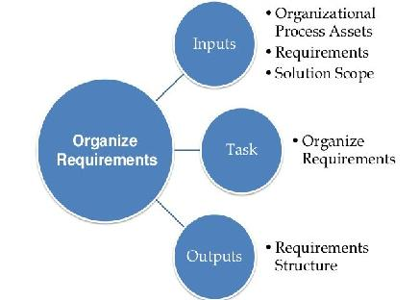

3.6.5Portability:

The application is DB2 based and should be compatible with all other systems which have a native .NET implementation. The end-user part is fully portable and any system using any web browser should be able to use the features of the application, including any hardware platform that is available or will be available in the future.

3.7 Organizing the Specific Requirements

3.7.1 Function Hierarchy

Definition:

A function hierarchy is a freely-definable structure used to organize functions.

Use:

The function hierarchy organizes the available functions in the applicable process template environment according to their uses or other characteristics.

The active function hierarchy serves as the basis for determining the list offered by the possible entries function in each applicable context.